**Deploy Nginx container on Windows using Ansible**

Windows Server Core image with Nginx installed.

Nginx isn't tweaked for Windows in the way it is for Linux. It is functional but doesn't have the performance and scale - it's considered a [beta version](http://nginx.org/en/docs/windows.html).

**Run Nginx:**

docker run -d -p 80:80 --name nginx sixeyed/nginx:windowsservercore

**Configure Windows host for remote management with Ansible:**



This script checks the current WinRM (PS Remoting) configuration and makes the necessary changes to allow Ansible to connect, authenticate and execute PowerShell commands.

Inventory.yaml File:

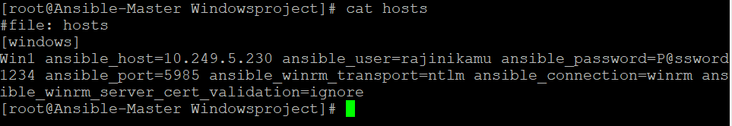

Start Nginx container using docker.yaml file:

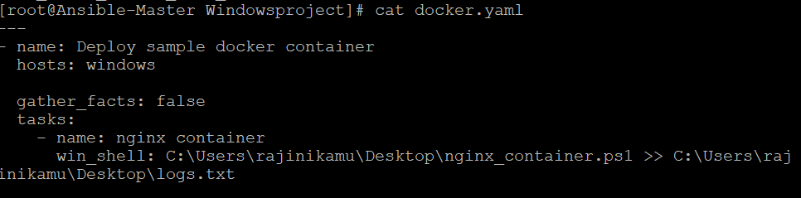

Nginx.container.ps1 file:

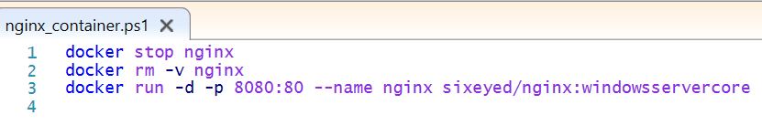

Executing Ansible playbook.

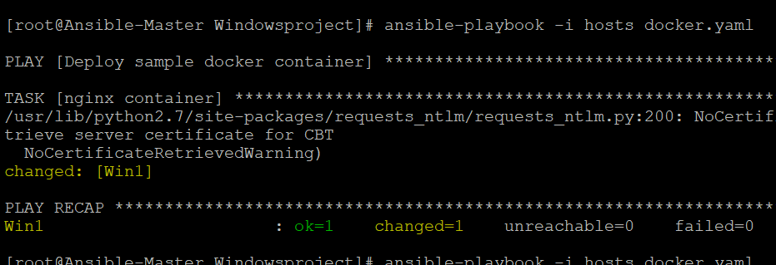

Output:





Log output:

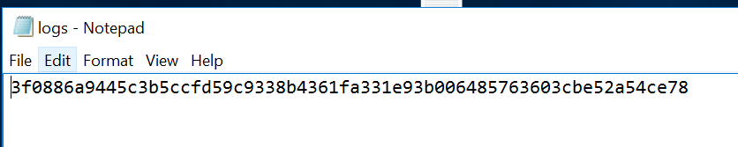

Execute IP address of the container to view the welcome screen:

